**CSCE 110: Programming I**

**Lab 5**

**General Instructions:**

* The lab is due online by 11:59 pm of the due date. The assignment must be typed, not handwritten, or scanned.
* Label your Python programs L5q<num>.py, where num is the question number. For example, your solution to the first question will be stored in the file L5q1.py.
* Make sure you understand everything in this lab before getting started. Also, make sure that your programs match the output exactly as given for each question. This is important as one of the keys to being a good programmer is attention to detail.
* Grading is based on correctness and clarity.
* **Copying work from another source and submitting it as your own is plagiarism and a violation of the code of honor. The minimum penalty for plagiarism is a grade of zero and will be reported to the Aggie honor system office.**

**Lab Questions**

1. A prime number is a number greater than 1 that is only evenly divisible by itself and 1. For example, the number 11 is prime because it can only be evenly divided by 1 and 11. The number 12, however is not prime because it can be divided evenly by 1, 2, 3, 6, and 12. In a file Lab5.py, write a Boolean function named is_prime() which takes an integer as an argument and returns **True** if the argument is a prime number, or **False** otherwise. Write a program that displays all of the prime numbers less than 500. The program should have a loop which calls the is_prime() function.
2. *Combinations*: Suppose, you have *n* objects and you need to choose *k* objects from those. Obviously, n, k should be non-negative and k must not be larger than n. There are multiple ways you can choose and you need to calculate the total number of ways. This is known as a ***combination***, and it can be calculated using the formula: 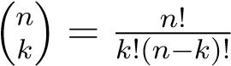.   
   Here, *n*! means factorial of *n*, i.e. *n*! = 1 × 2 × 3 × ...... × *n.* By definition, 0! = 1.

In a file L5q2.py: write a function named my_factorial() which will compute and return *n*!; a function named my_combination() to calculate and return the number of combinations given the values of *n* and *k* using my_factorial() to aid in the calculation; and a program which will prompt the user to input values of *n* and *k,*  call my_combination(), and display the number of combinations. Your input should be validated to ensure that 0 ≤ *k* ≤ *n*.  
  
**Example #1**. The user enters *n* and *k* (lines 1–2). The program then prints combination output. (line 4).  
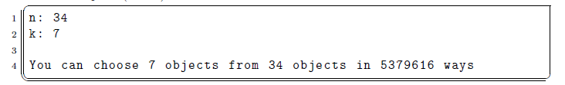

**Example #2**. The user enters *n* and *k* (lines 1–2). The program then prints combination output. (line 4).

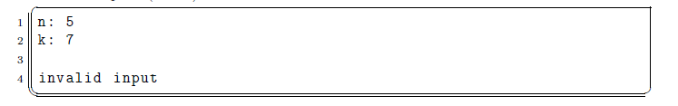

**Example #e**. The user enters *n* and *k* (lines 1–2). The program then prints combination output. (line 4).

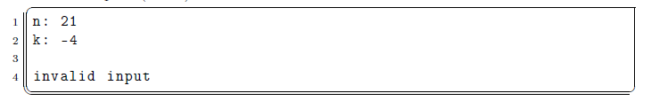

**Submitting Your Assignment**

Once you have completed your programs, submit each of them (L5q1.py, L5q2.py) electronically.

You may resubmit your files as many times as you need until the due date. Only the most recent submission is graded.

You are required to include the following lines in the header of all your files:

|  |
| --- |
| **# File: filename.py # Author: Student name # Date: xx/xx/2021 # Section: Student section number  # E-mail: student_email@tamu.edu  # Description: # e.g. This program asks for ...** |

Submit your files on [gradescope.com](https://www.gradescope.com/)